

Practices for Secure Software Report

Table of Contents
Document Revision History 3
Client 3
Instructions 3
Developer 4
1. Algorithm Cipher 4
2. Certificate Generation 4
3. Deploy Cipher 4
4. Secure Communications 4
5. Secondary Testing 4
6. Functional Testing 4
7. Summary 4
8. Industry Standard Best Practices 4

Document Revision History

Version | Date | Author | Comments
1.0 | 14DEC25 | Jacob Brents

Client



Instructions

Submit this completed practices for secure software report. Replace the bracketed text with the relevant information. You must document your process for writing secure communications and refactoring code that complies with software security testing protocols.

- Respond to the steps outlined below and include your findings.
- Respond using your own words. You may also choose to include images or supporting materials. If you include them, make certain to insert them in all the relevant locations in the document.
- Refer to the Project Two Guidelines and Rubric for more detailed instructions about each section of the template.

Developer
Jacob Brents

Algorithm Cipher

- Provide a brief, high-level overview of the encryption algorithm cipher.
For this assignment, I’m going to recommend using SHA-256 with RSA-2048. SHA-256 is a popular secure hash algorithm due to its 256-bit (32-byte) hash value. That will be used for the file verification and provide a checksum. RSA-2048 will be used for asymmetric encryption during key exchange and certificate authentication.
- Discuss the hash functions and bit levels of the cipher.
SHA-256 produces a 256-bit hash, and RSA-2048 uses 2048-bit keys for encryption and decryption. Together, they create a secure environment with RSA-2048 encryption keys and authenticating certificates, and SHA-256 being used for file verification.
- Explain the use of random numbers, symmetric versus non-symmetric keys, and so on.
So, symmetric encryption uses a single key for both encryption and decryption, and asymmetric encryption uses a pair of keys for encryption and decryption. Usually, a public key is for encryption and a private key for decryption, and RSA-2048 is asymmetrical. Random numbers provide greater security by avoiding patterns.
- Describe the history and current state of encryption algorithms.
As algorithms have advanced from 56 bits to 512 bits, the speed at which they are processed has increased, allowing more bits to be processed in less time. Currently, 512 bits seems future-proof, even for when quantum computing comes around, but eventually that will have to be raised as technology advances.

Certificate Generation
Insert a screenshot below of the CER file.

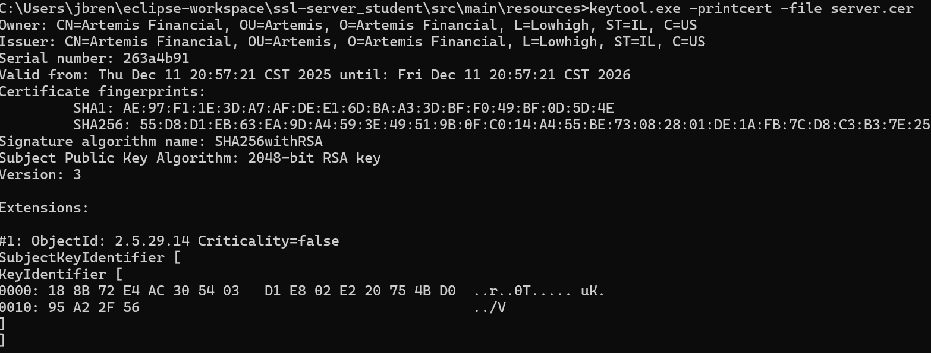

Deploy Cipher
Insert a screenshot below of the checksum verification.

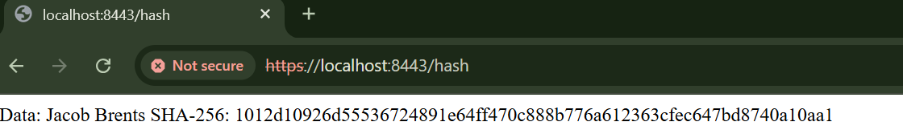

Secure Communications
Insert a screenshot below of the web browser that shows a secure webpage.

I could not get a secure webpage to show because to have trust, I would have to install this certificate in the Trusted Root Certification Authorities Store.
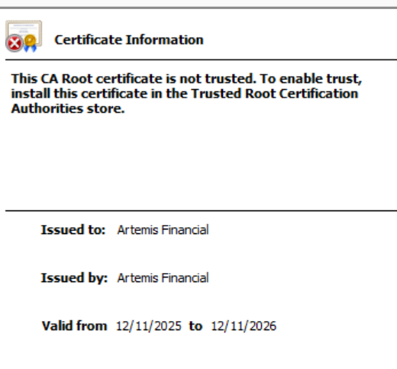

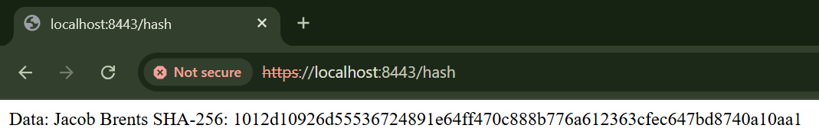

Secondary Testing
Insert screenshots below of the refactored code executed without errors and the dependency-check report.

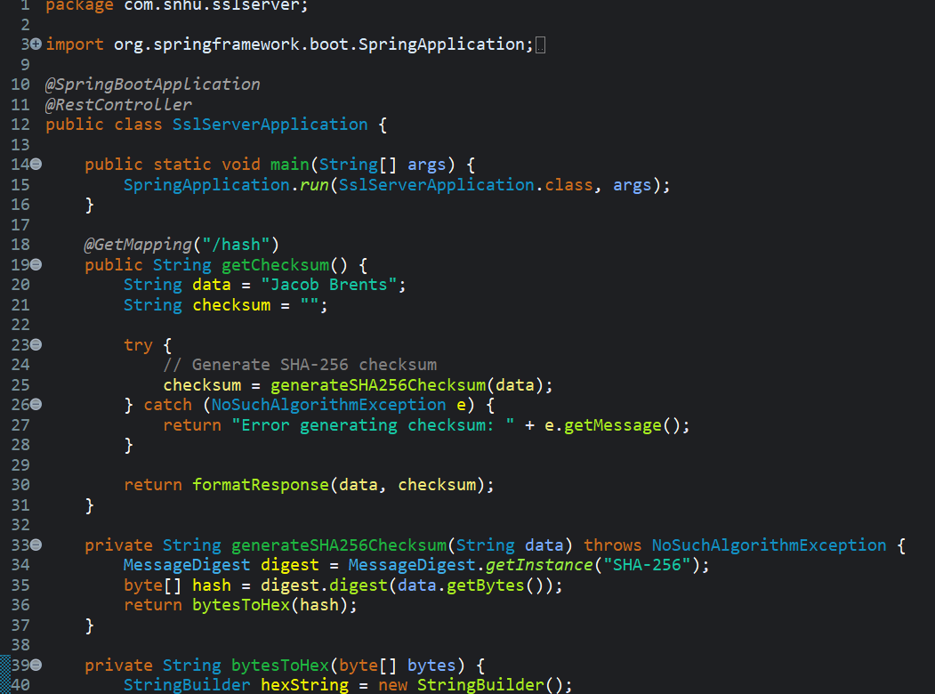
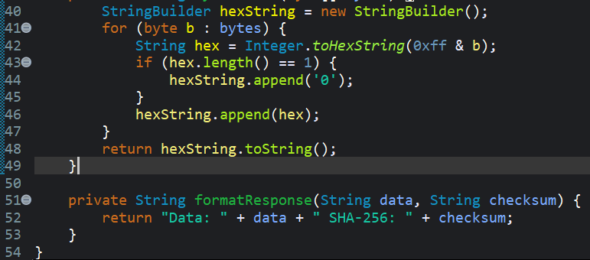

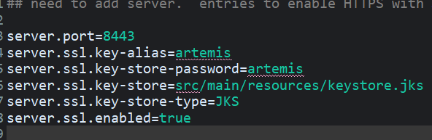

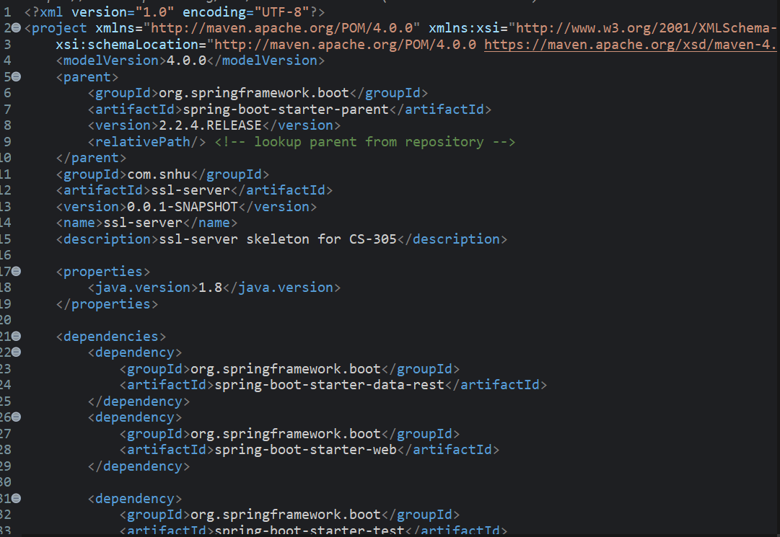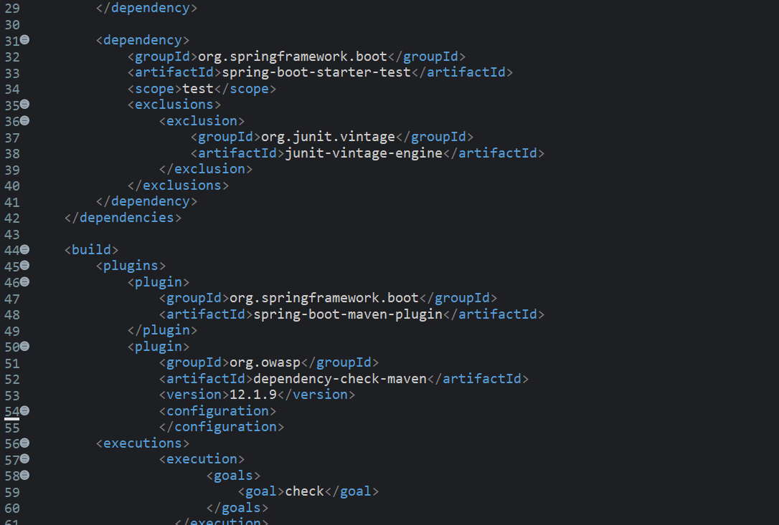

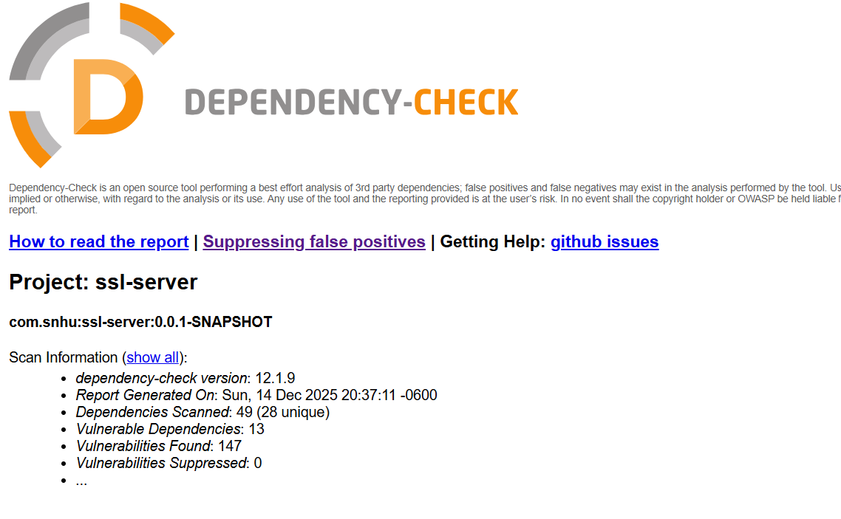

Functional Testing

Insert a screenshot below of the refactored code executed without errors.



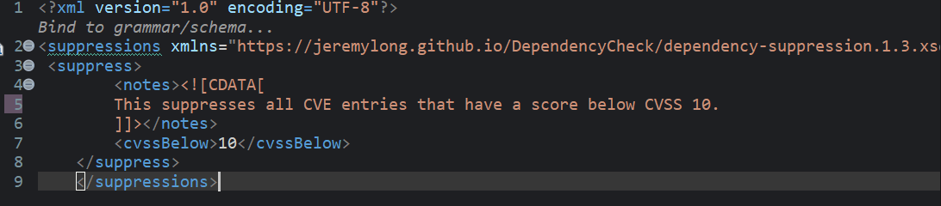

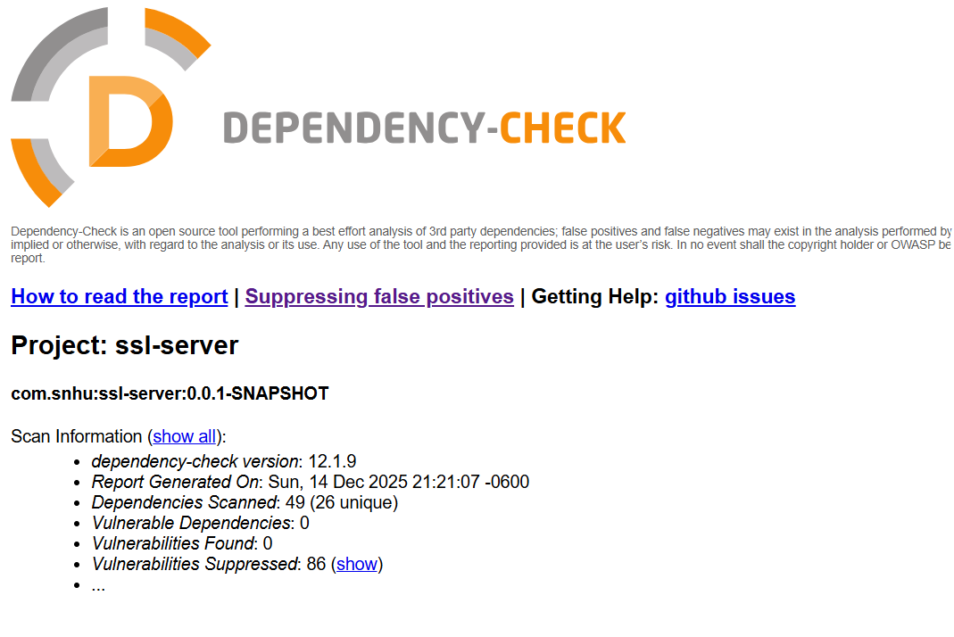

Summary

- Refer to the vulnerability assessment process flow diagram in the Supporting Materials section. Highlight the areas of security that you addressed by refactoring the code.
Some of the areas addressed in the vulnerability assessment flow diagram included input validation, cryptography, code errors, and code quality. For input validation, there are exceptions to protect against malicious input. In cryptography, modern algorithms are used to protect users.
- Discuss your process for adding layers of security to the software application.
Ultimately, I wanted to ensure safe, but efficient, use by verifying SHA-256 checksums and providing HTTPS services (though the self-sign kept us from being fully certified). The added code quality and input validation made the program safer, but I did skimp on checking all the vulnerabilities because I was running low on time. I also understand that the way I suppressed the alarms was a big no-no, but I had to check boxes to get the highest grade possible in the least time.

Industry Standard Best Practices

- Explain how you used industry standard best practices to maintain the software application’s existing security.
To start, the SHA-256 hash function was employed for this project, which is one of the more secure algorithms for years to come, ensuring user security and reducing worry on the company side. The program also uses HTTPS, which gives users peace of mind and holds the company accountable if they become complacent about their security. Then, using exceptions for input validation is an easy way for developers to be proactive in the DevSecOps.
- Explain the value of applying industry standard best practices for secure coding to the company’s overall well-being.
I explained a little bit of it above. Still, secure coding throughout the development process can cut down on development time and ensure user safety is considered the whole way through, not abandoned if security doesn’t align with the current code. It also builds trust between the company and users and ensures that people continue to use its services and programs.

